# Grade Archive System for Bangkal Main Elementary School with Implementation of AWS

Project Documentation Submitted

to the Faculty of School of

Computing and Information Technologies

of

Asia Pacific College

In Partial Fulfillment of the Requirements for the Subject

Introduction to Systems Development (INTSDEV)

By

Patrick Cedie P. Adriano

Mark Justine V. Apit

Tyrone Edward B. Fonacier

**ASIA PACIFIC COLLEGE**

# Approval Sheet

GRADE ARCHIVE SYSTEM BANGKAL MAIN ELEMENTARY SCHOOL WITH IMPLEMENTATION OF AWS

Prepared and Submitted by:

Patrick Cedie P. Adriano

Mark Justine V. Apit

Tyrone Edward B. Fonacier

In Partial Fulfilment of the Requirements for the Degree of

Bachelor of Science in Computer Science with Software Development

Examined and Recommended for Acceptance and Approval for Research/Capstone Presentation

\_\_\_\_\_\_\_\_\_\_\_\_\_\_\_\_\_\_\_\_\_\_\_\_\_\_\_

Adviser

Panel of Judges

\_\_\_\_\_\_\_\_\_\_\_\_\_\_\_\_\_\_\_\_\_\_\_\_\_\_\_

Chairperson

Panel Members

\_\_\_\_\_\_\_\_\_\_\_\_\_\_\_\_\_\_\_\_\_\_\_\_\_\_\_ \_\_\_\_\_\_\_\_\_\_\_\_\_\_\_\_\_\_\_\_\_\_\_\_\_\_\_

Panel Member Panel Member

Acceptance and Approved in partial fulfillment of the requirements for the degree of Bachelor of Science in Computer Science with Software Development

\_\_\_\_\_\_\_\_\_\_\_\_\_\_\_\_\_\_\_\_\_\_\_\_\_\_\_\_\_\_\_

Executive Director

School of Computing and Information Technologies

Table of Contents

[Grade Archive System for Bangkal Main Elementary School with Implementation of AWS 1](#_Toc511975761)

[Approval Sheet 2](#_Toc511975762)

[Abstract 4](#_Toc511975763)

[List of Figures, List of Tables, List of Notations 5](#_Toc511975764)

[I. Introduction 6](#_Toc511975765)

[1.1 Project Context 6](#_Toc511975766)

[1.2 Statement of the Problem 6](#_Toc511975767)

[1.3 Purpose and Description 6](#_Toc511975768)

[1.4 Objectives 7](#_Toc511975769)

[1.5 Scope and Limitations 7](#_Toc511975770)

[II. Related Literature 7](#_Toc511975771)

[III. Technical Background 9](#_Toc511975772)

[IV. Design and Methodology 14](#_Toc511975773)

[4.1 Requirements Analysis 14](#_Toc511975774)

[4.2 Requirements Documentation 15](#_Toc511975775)

[4.3 Gap Analysis/Needs Assessment 21](#_Toc511975776)

[4.4 Design of Software, Systems, Product, and/or Process 21](#_Toc511975777)

[4.5 System Architecture 21](#_Toc511975778)

[V. Results and Discussion 22](#_Toc511975779)

[VI. UML Diagrams 23](#_Toc511975780)

[6.1 Use Case Diagram 23](#_Toc511975781)

[6.2 Context Level Diagram 24](#_Toc511975782)

[6.3 Data Flow Diagram Level 1 24](#_Toc511975783)

[6.4 Data Flow Diagram Level 2 25](#_Toc511975784)

[6.5 Entity Relationship Diagram 26](#_Toc511975785)

[6.6 Activity Diagram 27](#_Toc511975786)

[6.7 System Sequence Diagram 28](#_Toc511975787)

[6.8 Object Diagram 28](#_Toc511975788)

[6.9 Class Diagram 29](#_Toc511975789)

[VII. Appendices 29](#_Toc511975790)

# Abstract

The fast processing of information is a must when competing in the business world. Being able to process the information in a short period of time results in more productivity.

In this paper, the researchers proposed a grade archive system for Bangkal Main Elementary School that aims to digitize all grade records of the students from kindergarten to grade 6. The system will be cloud-based using Amazon Web Services (AWS). All confidential information will be secured using Advanced Encryption Standard (AES).

# List of Figures, List of Tables, List of Notations

[Figure 1. Cloud Computing Architecture 9](#_Toc511975803)

[Figure 2. Web Application in AWS Cloud 10](#_Toc511975804)

[Figure 3. Symmetric Database Encryption 12](#_Toc511975805)

[Figure 4. Flow of AES Algorithm 13](#_Toc511975806)

[Figure 5. Events Table 14](#_Toc511975807)

[Figure 6. Input Grades 15](#_Toc511975808)

[Figure 7. Save ECR 16](#_Toc511975809)

[Figure 8. Print ECR 17](#_Toc511975810)

[Figure 9. Submit Data 18](#_Toc511975811)

[Figure 10. Produce Transcript of Record 19](#_Toc511975812)

[Figure 11. Storing in the Database 20](#_Toc511975813)

[Figure 12. System Architecture 22](#_Toc511975814)

[Figure 13. Use Case Diagram 23](#_Toc511975815)

[Figure 14. Context Level Diagram 24](#_Toc511975816)

[Figure 15. Data Flow Diagram Level 1 24](#_Toc511975817)

[Figure 16. Data Flow Diagram Level 2 25](#_Toc511975818)

[Figure 17. Entity Relationship Diagram 26](#_Toc511975819)

[Figure 18. Activity Diagram 27](#_Toc511975820)

[Figure 19. System Sequence Diagram 28](#_Toc511975821)

[Figure 20. Object Diagram 28](#_Toc511975822)

[Figure 21. Class Diagram 29](#_Toc511975823)

# Introduction

## Project Context

The continuous growth of technology leads to the birth of countless innovations. Innovations that allow people to increase their productivity in a short amount of time. People have shifted from the conventional paper-based system to electronic storage of information, from the manual processes of transferring letters to using electronic mails. People need to process information fast to be able to compete in the business world. Over the years, the Philippines have been catching up with the rest of the world in terms of technological growth. One factor remains unchanged and that is the public schools’ process of storing their students’ grades. They stick to the usage of paper in creating records of the students. This method possesses handful of problems which can result in the occurrence of a more complex problem.

## Statement of the Problem

In Bangkal Main Elementary School, the team interviewed a teacher as well as a class adviser about the processes that has concern about the students’ grades. During the interview, the team noticed potential problems that can arise. These are:

1. Prone to Damage - Teachers sometimes manually record the students’ grades on paper. The papers are vulnerable to decay and torn due being stored for too long.
2. Usage of ECR is Difficult - The teachers use Electronic Class Record in storing the students’ grades. Teachers need to download the spreadsheets from multiple sources online and the storage of the files require a flash drive making the usage of ECR difficult. Even with ECR implemented teachers uses paper to create a backup record called SF5. SF5 only keeps the average of the subjects.
3. Inefficient Storage – The teachers produces a lot of documents in keeping track of the students’ progress. This will involve the usage of a lot of papers which will take up a lot of physical space and effort to keep it organized.
4. Time-Consuming – With a lot of records in storage, looking for a single document can take a lot of time which can cause delay.
5. Teacher Unavailability – There are instances that subject teachers can’t pass the grade records because the class adviser is unavailable. There were tendencies that the subject teacher will just leave the record on the adviser’s table and with that the record got lost at some point.

## Purpose and Description

The main purpose of the proposed system is to provide Bangkal Main Elementary School a centralized grade archive system. The team will base the system on the existing grading processes of the school. This includes, who gets to hold the grade and what corresponding action they can do with it. By using Advanced Encryption Standard(AES) the system secures the confidential data or information, like student grades, which can only be accessed by registered school personnel. Digitizing all the grade records, including the backups, eliminates the usage of paper. By using Amazon Web Service(AWS), the data is on the cloud which enables the teacher to take their work anywhere as long as they are connected to the internet allowing them to grade their student with no delay.

## Objectives

The proposed system aims to:

1. Digitize all the grade records, including the written backup records, to eliminate the usage of paper. The digitized records will be put in the secured cloud which will not take up physical space and will require minimum effort to organize.
2. Secure the records using encryption that only gives access to registered school personnel.
3. Remove the manual transferring of files via flash drive or written record. The record can be readily accessed by authorized school personnel through online.

## Scope and Limitations

The researchers focused on the processes of recording and storing of grades on Bangkal Main Elementary school from kindergarten to grade 6. The researchers will use the processes gathered from Bangkal Main Elementary School as a basis in developing the integrated system. The system is only accessible when connected to the internet.

# Related Literature

#### Document Management System (DMS)

In today's business environment, most businesses, from small businesses to large corporate entities, organize and maintain a tremendous amount of information, particularly information in the form of paper-based documents and electronic documents. The task of organizing and maintaining such a large number of documents, as well as document types is time consuming and costly matter.

According to Kelemen, R., & Mekovec, R. (n.d.) due to the pain of searching for documents for extensive span of time and manually handling documents, many firms started implementing Document Management System (DMS). A DMS refers to the repository that store documents and allows end-users to retrieve and track documents. A research conducted by Robert Kelemen and Renata Hudek shows the advantages of having a DMS. The specified advantages are:

* Faster document distribution and retrieval;
* Centralization of archiving; accessibility, security and control;
* It makes work with customers and the decision-making process easier
* Better distribution of work;
* Better electronic documents handling;
* It has no time-consuming document handling, archiving and searching;
* Less space for achiving;
* It reduces labour and streamline processing through automated workflow features;
* It provides more convenient and faster access to case files;
* It eliminates lost and misplaced files.

#### Using Spreadsheets to Keep Track of Students' Grades

According to Richard Zach (2005) spreadsheet programs like Microsoft Excel can be used to manage grade sheets productively. It provides a secure and clean way of storing grade records, and it can also be applied to uncomplicated tasks like converting alphabetical grades into numerical figures and the other way around. The first thing the user needs to do in setting up the grade sheet is to gather all the information needed in the grade sheet. The student names and ID numbers would be the most important, but having other information might be helpful sometimes.

#### Electronic Class Record (ECR)

DepEd announced that all public school teachers should follow and use the official and standard Electronic Class Records (ECR) for all the curriculums’ subjects. This is to ensure the accuracy of grading and ranking of students. The ECR templates were simplified by DepEd, this is to guarantee sustainability and to minimize technical difficulty for the teachers. The ECR is very convenient for teachers to use. They can easily access it from their mobile phones, tablets, and computers. They just need to enter the score or grade of their students.

# Technical Background

##### *Cloud Computing*

### C:\Users\Ced\AppData\Local\Microsoft\Windows\INetCache\Content.Word\cloud_computing-what_is_cloud_computing.jpgFigure 1. Cloud Computing Architecture

Cloud computing is a computing style in which scalable and flexible IT functionalities are delivered as a service to external customers using Internet technologies.

Cloud applications extend their accessibility through the Internet by using large data centers and powerful servers that host web applications and services. Anyone with a suitable Internet connection and a standard Internet browser can access a cloud application.

Amazon Web Services (AWS) is a subsidiary of Amazon.com. It provides a secure cloud services platform, such as computing power, storage options, networking and databases, delivered as a utility: on-demand, available in seconds, with pay-as-you-go pricing.

The group will be using AWS services namely Amazon Elastic Compute Cloud (EC2) for web service and application, and Amazon Relational Database Service (RDS) for a database storage server.

##### *Amazon Elastic Compute Cloud (EC2)*

Amazon Elastic Compute Cloud (Amazon EC2) provides scalable computing capacity in the Amazon Web Services (AWS) cloud. Using Amazon EC2 eliminates your need to invest in hardware up front, so you can develop and deploy applications faster. You can use Amazon EC2 to launch as many or as few virtual servers as you need, configure security and networking, and manage storage.

##### *Amazon Relational Database Service (RDS)*

Amazon Relational Database Service (Amazon RDS) is a web service that makes it easier to set up, operate, and scale a relational database in the cloud. It provides cost-efficient, resizable capacity for an industry-standard relational database and manages common database administration tasks.

##### *Web App on AWS Virtual Private Cloud*

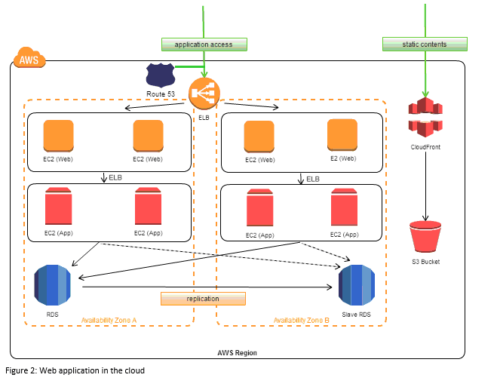

### Figure 2. Web Application in AWS Cloud

The following diagram shows example architecture for a web app. The web and application tiers run on EC2 instances in public subnets. Access to the EC2 instances over Secure Shell (SSH) is controlled by a security group, which acts as a firewall. The Auto Scaling group maintains a fleet of EC2 instances that can scale to handle the current load. This Auto Scaling group spans multiple Availability Zones to protect against the potential failure of a single Availability Zone. The load balancer distributes traffic evenly among the EC2 instances. When the Auto Scaling group launches or terminates instances based on load, the load balancer automatically adjusts accordingly. The database tier consists of DB instances in private subnets, located in multiple Availability Zones for failover protection. Access to the DB instances from the EC2 instances is controlled by a security group. Amazon Route 53 provides secure and reliable routing of your domain name to your infrastructure hosted on AWS.

##### *Symmetric Encryption Algorithm*

For secure exchange of digital data, resulted in large quantities of different encryption algorithms this can be classified into two groups: Symmetric encryption algorithm (with shared secret key algorithms) and Asymmetric encryption algorithm (with public key algorithms). A key in cryptography is a piece of information that allows control over the encryption or decryption process. Symmetric key algorithms are in general much faster to execute electronically than asymmetric key algorithms. The most commonly used symmetric encryption algorithm is AES.

The input plain text and the cipher key are in state array fashion and hence known as a block cipher. The plaintext input are of fixed size, blocks of 128 bits and produces a block of cipher text of equal size for each plaintext block. The most commonly used symmetric encryption algorithms are the data encryption standard (DES), triple data encryption algorithm (TDEA) and advanced encryption standard (AES). In this research AES was implemented because it provides more secure algorithm than the others, and it is commonly used in records management system.

### Figure 3. Symmetric Database Encryption

Symmetric Encryption Algorithm is one of the features that all the data that will be stored and called, by the users, from the school’s cloud database will involve a shared secret key for security purposes. This is one of the most crucial functions of the system.

##### *AES Algorithm*

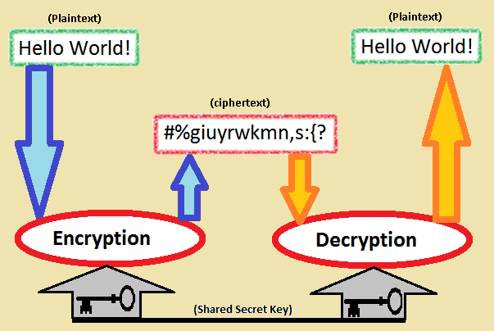The AES algorithm is a symmetric-key cipher, in which users uses a single key for encryption and decryption. The length of the plain text is fixed to be 128 bits, while the key length can be either 128,192, or 256 bits. The key length selected is of 128 bits. AES algorithm is an iterative algorithm. Every iteration can be called a round, and the total number of rounds is 10, 12, or 14, when key length is 128, 192, or 256 respectively. The 128 bit algorithm is divided into 16 bytes. These bytes are represented into 4x4 arrays called the state array, and all the different operations of the AES algorithm such as addroundkey, subbytes, shiftrows, mixcolumns and key expansion are performed on the state.

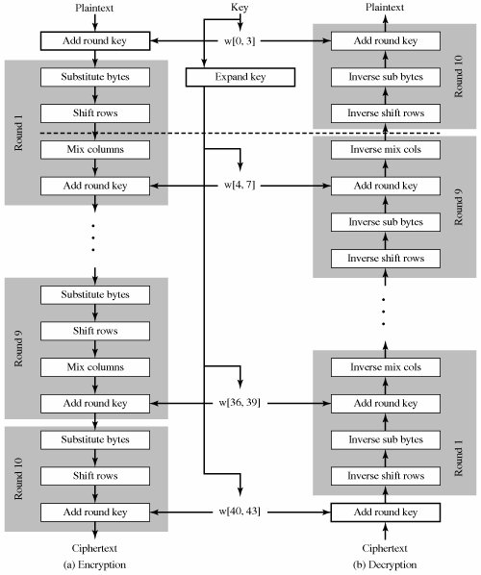

### Figure 4. Flow of AES Algorithm

The National Institute of Standards and Technology (NIST) started development of AES in 1997 when it announced the need for a successor algorithm for the Data Encryption Standard (DES), which was starting to become vulnerable to brute-force attacks.

##### *Hypertext Preprocessor (Php)*

PHP code may be embedded into HTML code, or it can be used in combination with various web template systems, web content management systems, and web frameworks.

##### *MySQL*

Is the world's most popular open source database. With its proven performance, reliability and ease-of-use, MySQL has become the leading database choice for web-based applications, used by high profile web properties including Facebook, Twitter, YouTube, Yahoo! and many more. Oracle drives MySQL innovation, delivering new capabilities to power next generation web, cloud, mobile and embedded applications.

##### *XAMPP*

XAMPP Stands for Cross-Platform (X), Apache (A), MariaDB (M), PHP (P) and Perl (P). It is a simple, lightweight Apache distribution that makes it extremely easy for developers to create a local web server for testing and deployment purposes.

# Design and Methodology

## Requirements Analysis

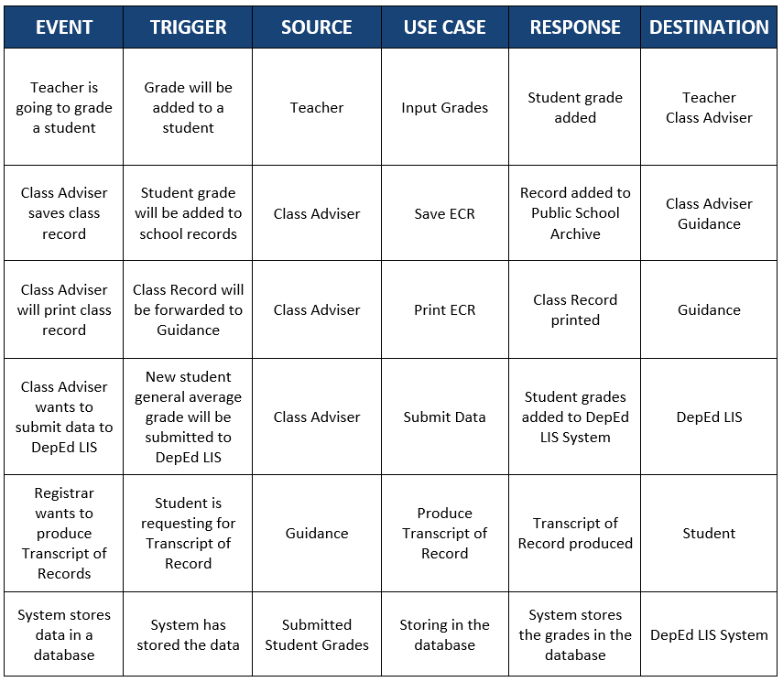

### Figure 5. Events Table

## Requirements Documentation

##### *Input Grades*

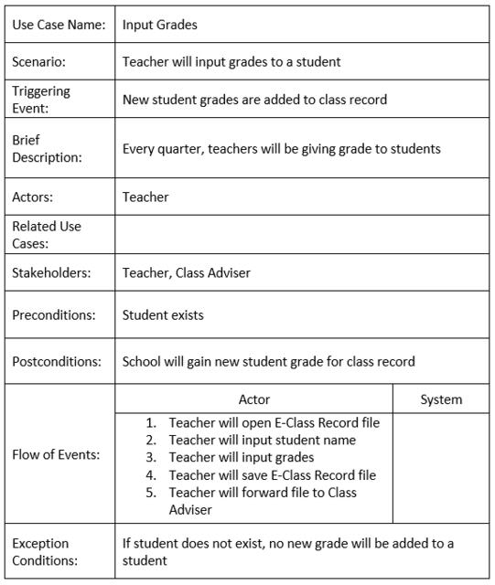

### Figure 6. Input Grades

##### *Save ECR*

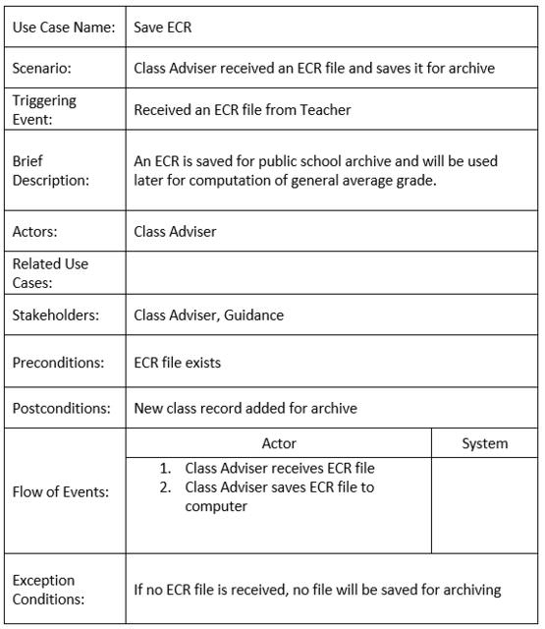

### Figure 7. Save ECR

##### *Print ECR*

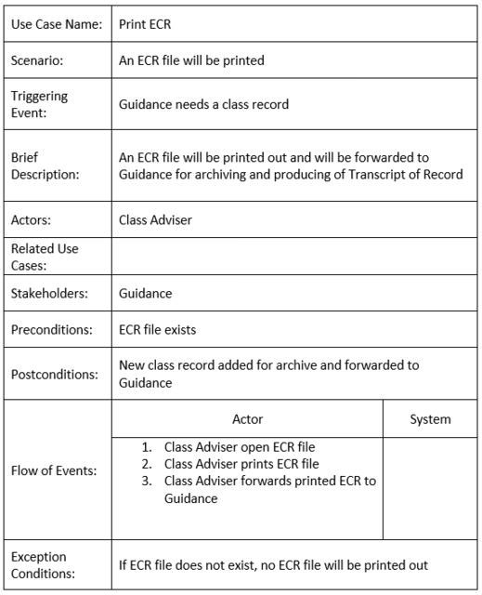

### Figure 8. Print ECR

##### *Submit Data*

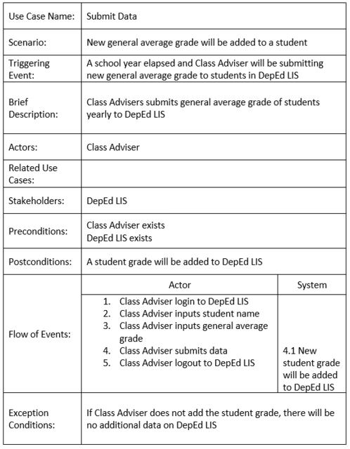

### Figure 9. Submit Data

##### *Produce Transcript of Record*

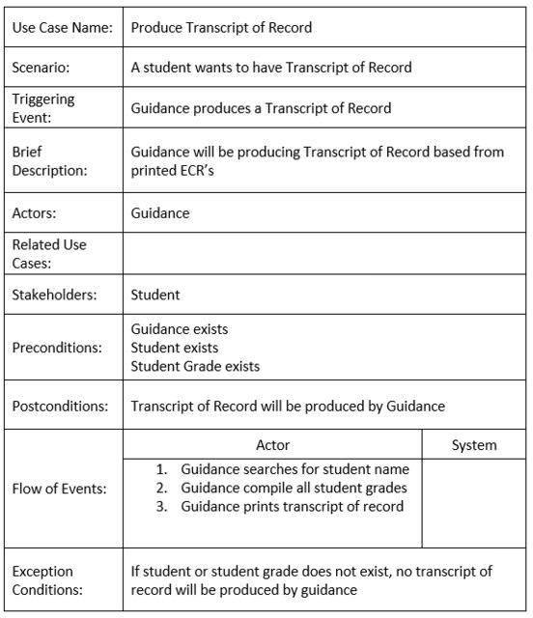

### Figure 10. Produce Transcript of Record

##### *Storing in the Database*

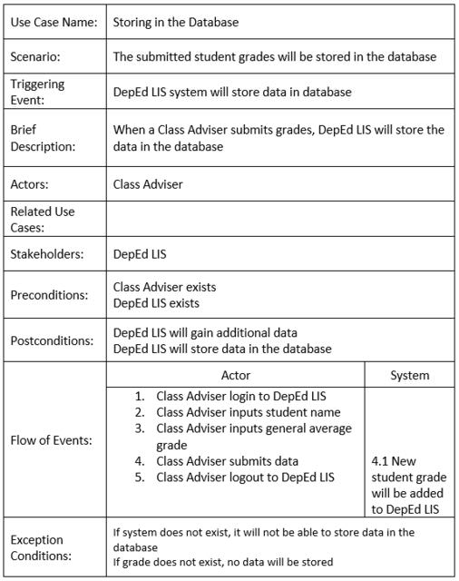

### Figure 11. Storing in the Database

## Gap Analysis/Needs Assessment

|  |  |  |  |
| --- | --- | --- | --- |
| User Requirements | Current System | Proposed Changes | Remarks/Impacts |
| An archive list of all the student’s information and subject grades with safe and secured storage | Records being printed and stored in file cabinets which takes a lot of paper and space in terms of storage | Provide a cloud based system where the school can store all records on a virtual storage with thorough encryption on every data | As compared to the current system that they use, implementing will consume less physical space. It is also a solution to the vulnerability of the manual records to decay or be destroyed. |
| To expedite the process of searching for a student record | The records of the students are currently searched manually in a huge pile of papers | Provide an archive system with a database that can arrange data in a systematic way | School personnel can now perform a range of simple to complex database queries to search for a student record |

## Design of Software, Systems, Product, and/or Process

The system is designed to confirm whether the personnel trying to access it is registered or not. If the system recognizes the personnel, it allows access to the database and enabling the school personnel to add or edit quarterly student grades. When grades are added, it will be encrypted and sent to the database which is in the cloud. The stored data can be viewed for future purposes

## System Architecture

In the Presentation Tier this would allow the intended end-users to access the system

through the use of a Web Browser and its Graphical User Interface. This layer can access the School Application that is intended for schools to use.

The Application Tier is where the cloud computing is being carried out. These connect the interface into the Database Tier for storing and retrieving of data from the database. The AES algorithm of symmetric database encryption will be implemented and executed in this part. AES is a security mechanism to be used for submission of student grade records to the database in the cloud. The student grade record is encrypted before sending it over the network.

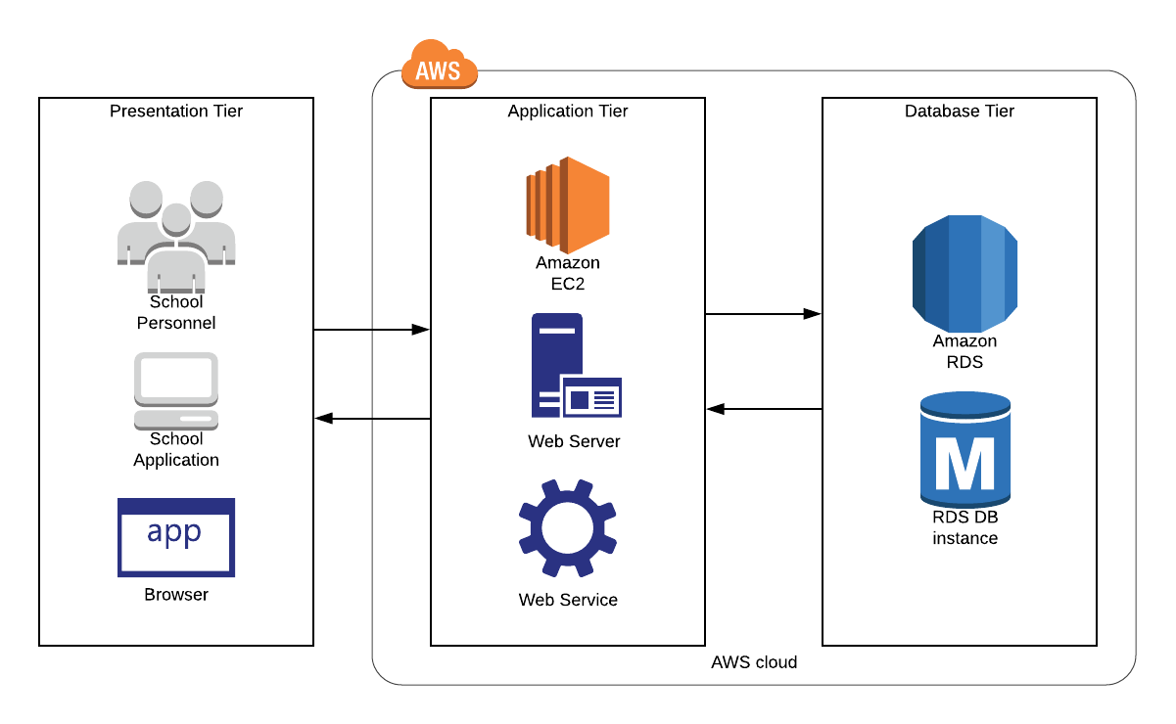 The Database Tier is where the database in cloud for the system is being handled.

### Figure 12. System Architecture

# Results and Discussion

Once the system is implemented and completely functional, school personnel’s productivity will increase. They will able to do it better when the documents can be accessed, edit and shared anytime, from anywhere. The records are also kept safe and secured.

# UML Diagrams

## Use Case Diagram

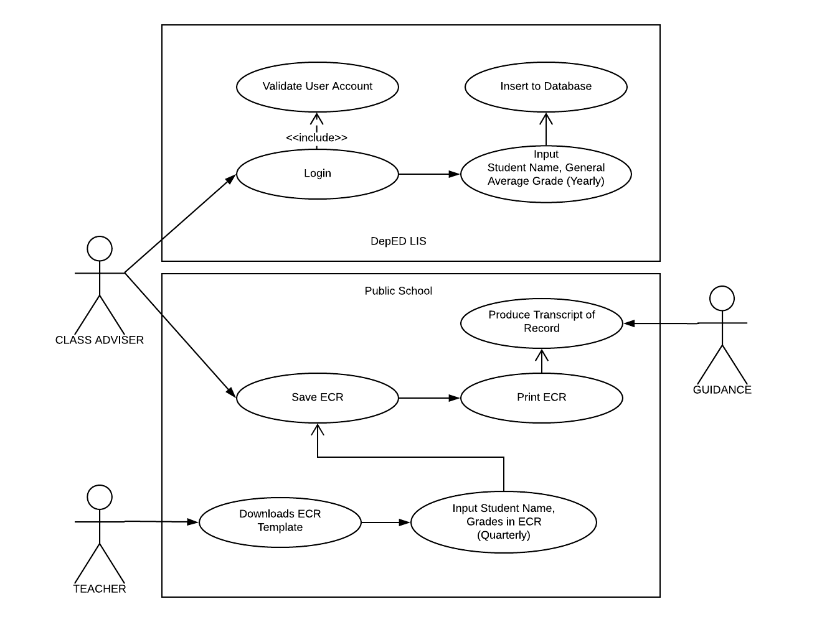

### Figure 13. Use Case Diagram

## Context Level Diagram

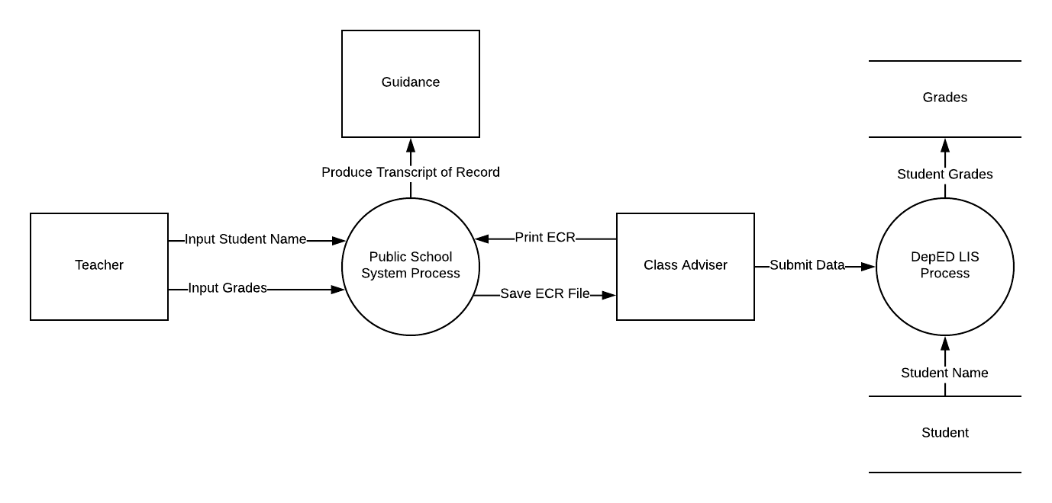

### Figure 14. Context Level Diagram

## Data Flow Diagram Level 1

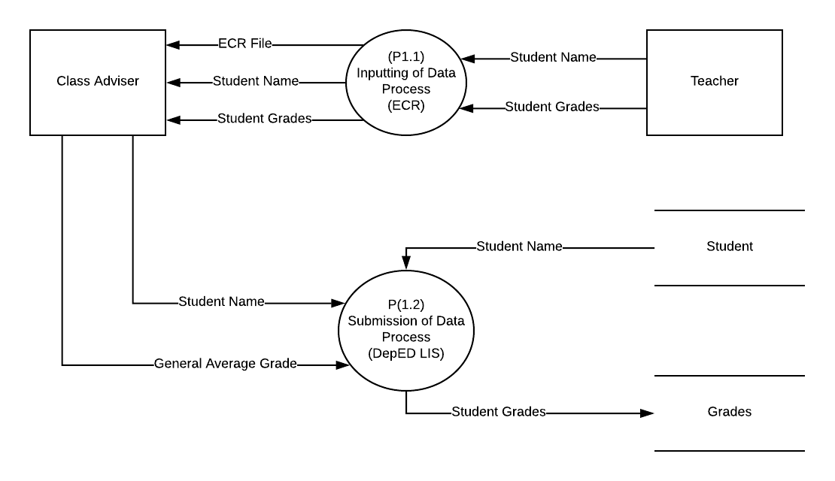

### Figure 15. Data Flow Diagram Level 1

## Data Flow Diagram Level 2

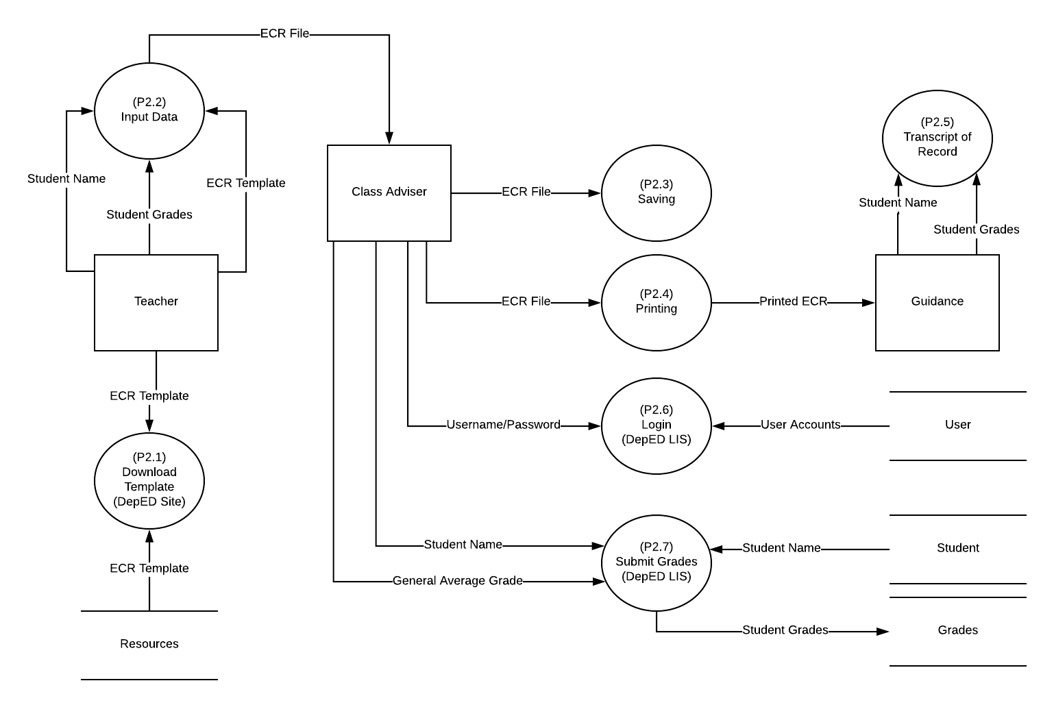

### Figure 16. Data Flow Diagram Level 2

## Entity Relationship Diagram

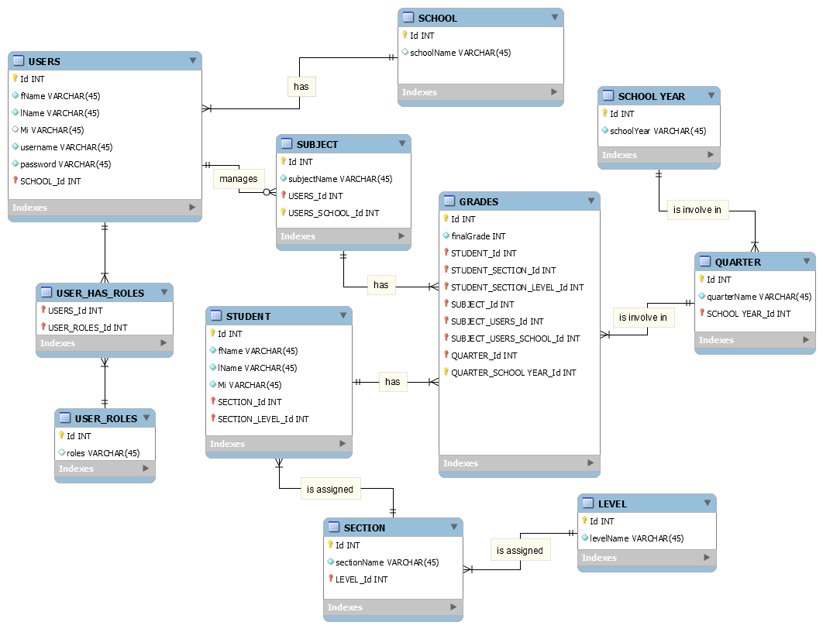

### Figure 17. Entity Relationship Diagram

## Activity Diagram

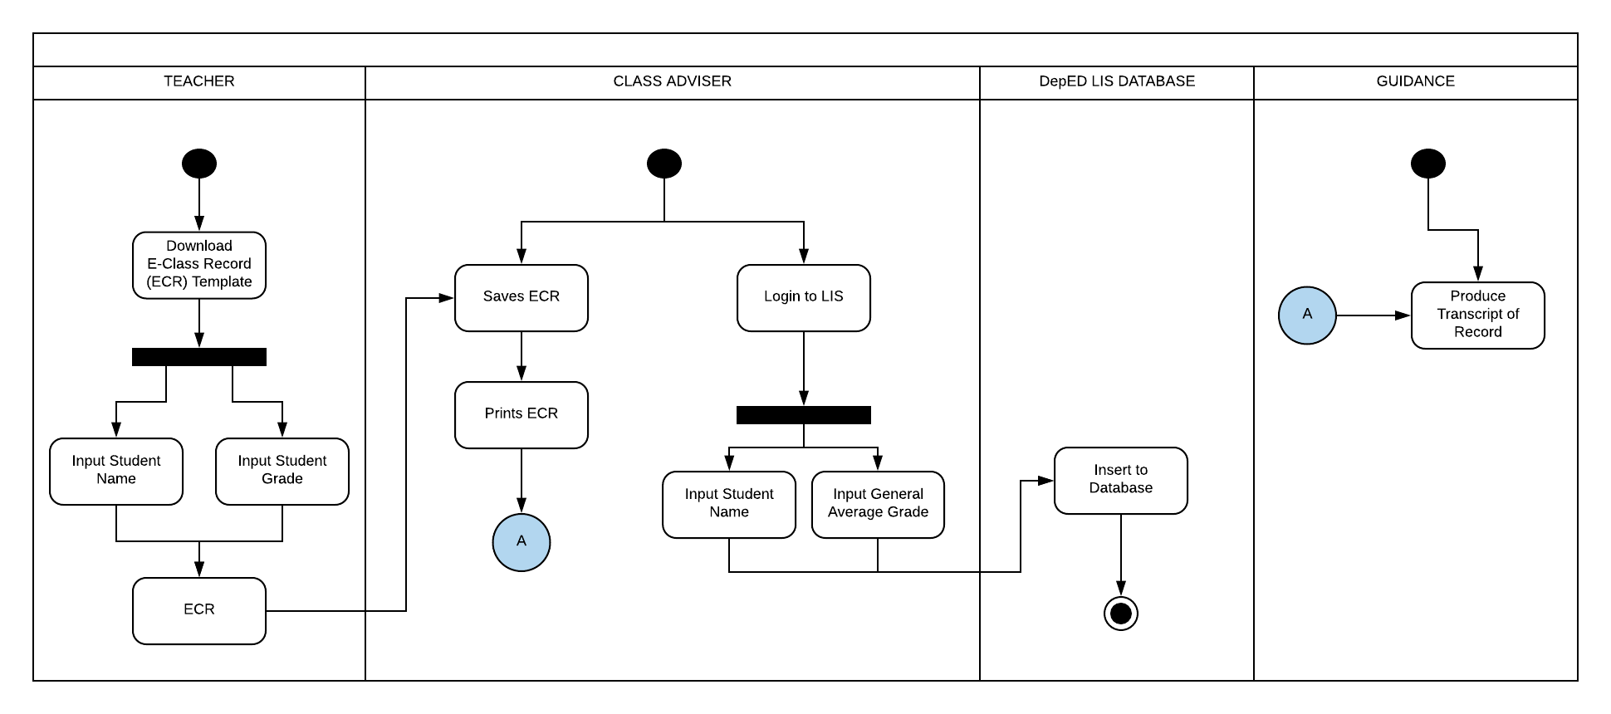

### Figure 18. Activity Diagram

## System Sequence Diagram

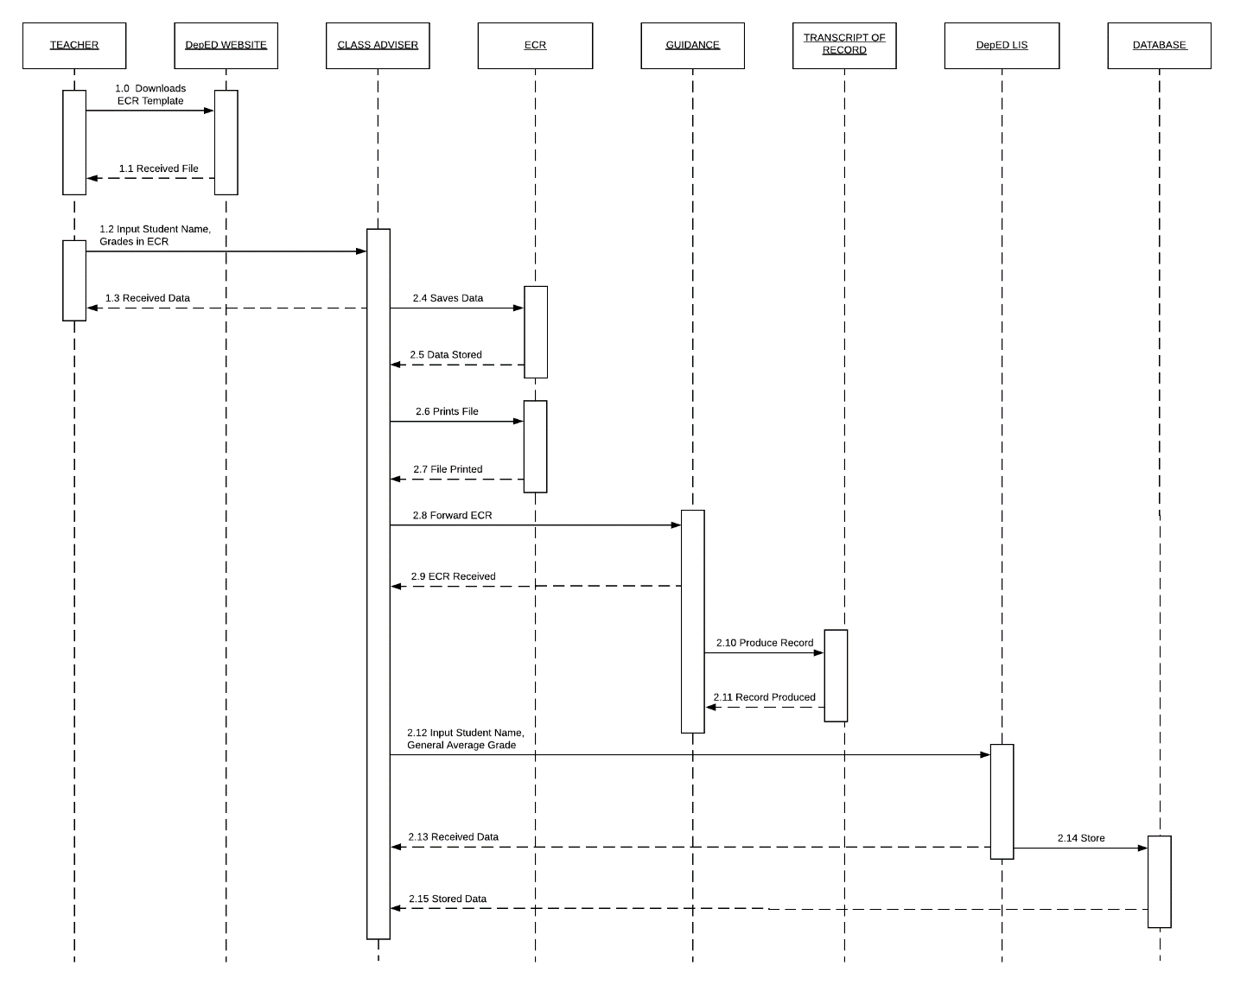

### Figure 19. System Sequence Diagram

## Object Diagram

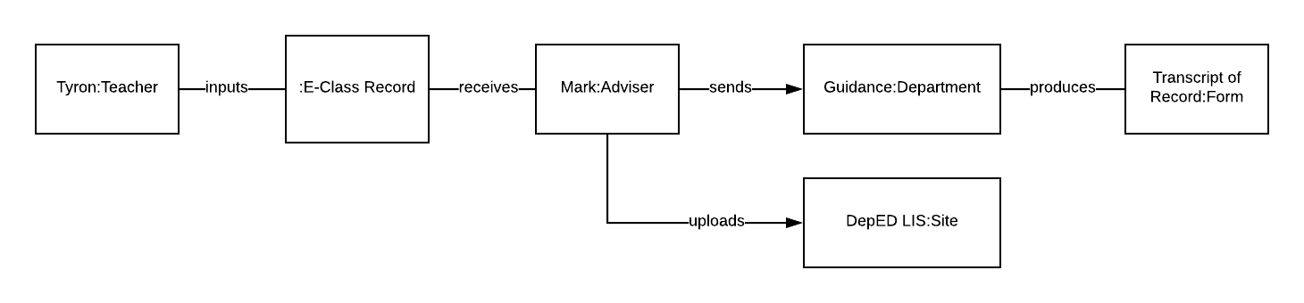

### Figure 20. Object Diagram

## Class Diagram

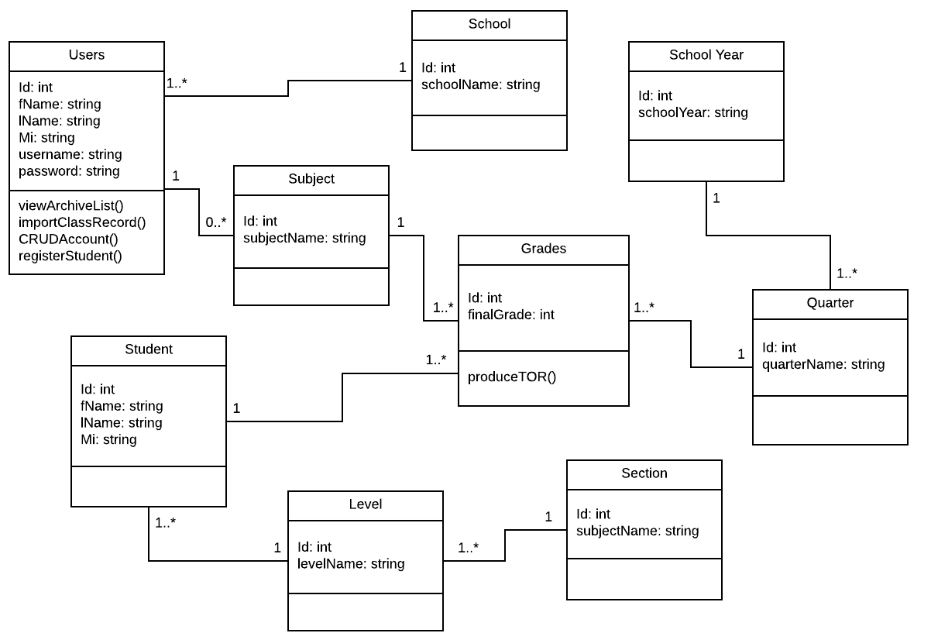

### Figure 21. Class Diagram

# Appendices

References

* Kelemen, R., & Mekovec, R. (n.d.). Document Management System. A Case Study of Verazdin Country, 1-6. Retrieved from: <https://bib.irb.hr/datoteka/345603.Kelemen-Mekovec_-_DMS_-_A_Case_Study_of_Varazdin_Counti_pp41-46s.pdf>
* K to 12 curriculum in the Philippines. (2015). What You Should Know about the New K to 12 Curriculum. Retrieved from: <http://k12philippines.com/an-overview-of-the-new-k-to-12-curriculum-in-the-philippines/>
* Zach, R. (2005). Using Spreadsheets to Keep Track of Students' Grades. Retrieved from: <https://www.ucalgary.ca/rzach/teaching/grades.html>
* Learner Information System (LIS) System Overview. (2017). 1-36. Retrieved from: <http://fape.org.ph/addons/tinymce/editor/media/articleimg/2016/DepEd%20Learner%20Information%20System%20(LIS).pdf>
* Yumi. (2017). Electronic Class Record. Retrieved from: <http://guroako.com/2017/04/23/e-classrecordelectronicclassrecord/>
* Rouse, M. (n.d.). Data Encryption Standard (DES) and Advanced Encryption Standard (AES). Retrieved from: <http://searchsecurity.techtarget.com/definition/Advanced-Encryption-Standard>